AT NIF
http://www.foxnews.com/scitech/2012/03/21/worlds-most-powerful-laser-fires-most-power-laser-blast-in-history/

World’s most powerful laser fires most powerful laser blast in history
Published March 21, 2012
FoxNews.com
- 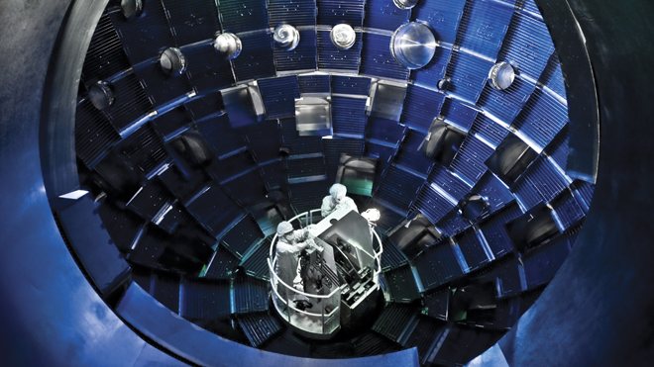
A service system lift allows technicians to access the target chamber interior at the National Ignition Facility for inspection and maintenance. (Lawrence Livermore National Laboratory)
- 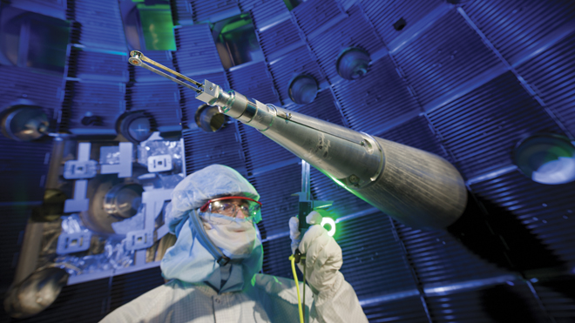
Before each experiment, a positioner precisely centers the target inside the target chamber and serves as a reference to align the laser beams. (Lawrence Livermore National Laboratory)
- 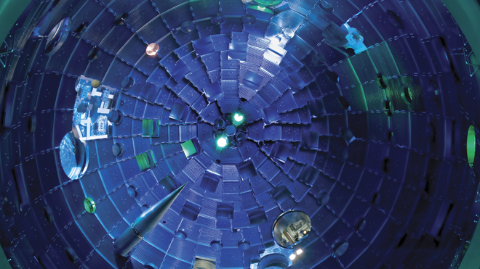
This view from the bottom of the chamber shows the target positioner being inserted. Pulses from NIF's high-powered lasers race toward the Target Bay at the speed of light. They arrive at the center of the target chamber within a few trillionths of a second of each other, aligned to the accuracy of the diameter of a human hair. (Lawrence Livermore National Laboratory)
- 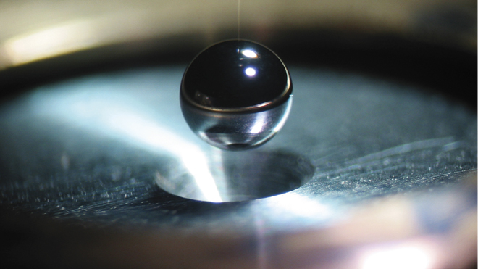
A NIF target contains a polished capsule about two millimeters in diameter, filled with cryogenic (super-cooled) hydrogen fuel. (Lawrence Livermore National Laboratory)
- 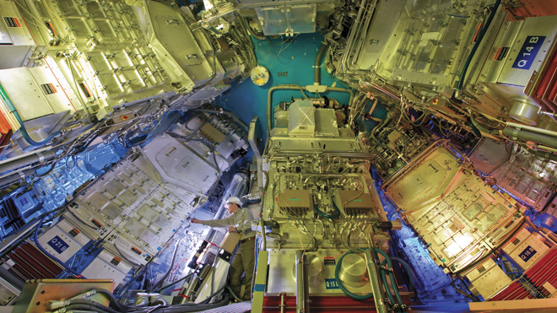
The final optics assemblies, shown here mounted on the lower hemisphere of the target chamber, contain special optics for beam conditioning, color conversion, and color separation. They also focus the beams from 40- by 40-centimeter squares of light to a spot on the target only 0.2 to 2 millimeters in diameter. (Lawrence Livermore National Laboratory)
Next Slide Previous Slide
The largest laser in the world was turned on for a fraction of a second last week -- and it unleashed the most powerful laser blast in history.
The National Ignition Facility (NIF) -- a laser test facility at Lawrence Livermore National Laboratory in Livermore, Calif. -- turned on its 192 laser beams for a brief instant on March 15, unleashing a record-setting 1.875-megajoule blast into a target chamber.
The lasers were combined, gathered and focused through a series of lens into a 2.03-megajoule shot, said Ed Moses, NIF director -- a record for the facility.
That pulse of energy lasted for just 23 billionths of a second, yet it generated 411 trillion watts of power, NIF said -- 1,000 times more than the entire United States consumes at any given instant.
“It’s a remarkable demonstration of the laser from the standpoint of its energy, its precision, its power, and its availability,” Moses told Nature magazine.
But it’s barely half the battle. NIF hopes to dramatically increase the power of the laser shots by the end of year, intending to ultimately use the facility to harness the energy reaction that occurs naturally within the sun: fusion.
“This event marks a key milestone in the National Ignition Campaign’s drive toward fusion ignition,” Moses said.
In fission, atoms are split and the massive energy released is captured. The NIF aims for fusion, the ongoing energy process in the sun and other stars where hydrogen and helium nuclei are continually fusing and releasing enormous amounts of energy. In the ignition facility, beams of light converge on pellets of hydrogen isotopes to create a similar, though controlled, micro-explosion.
As the beams move through a series of amplifiers, their energy increases exponentially. From beginning to end, the beams' total energy grows from one-billionth of a joule to a potential high of four million joules, NIF said -- a factor of more than a quadrillion.
And it all happens in about five millionths of a second.
Because the laser is on for the merest fraction of a second, it costs little to operate -- between $5 and $20 per blast, said spokeswoman Lynda Seaver. But the potential is enormous.
NIF’s managers hope by the end of the year to reach a break-even point, where the energy released is equal to if not greater than the energy that went into the blast.
“We have all the capability to make it happen in fiscal year 2012,” Moses told Nature.
Experts aren't so sure, citing challenges that NIF and other types of fusion have had in the past.
Glen Wurden, a plasma physicist at Los Alamos National Laboratory in New Mexico, told Nature scientists should be wary of putting all their eggs in the laser basket.
“It’s premature right now,” he told the magazine, citing the troubles that have plagued a competing approach to fusion and its flagship project in France.
Read more: http://www.foxnews.com/scitech/2012/03/21/worlds-most-powerful-laser-fires-most-power-laser-blast-in-history/#ixzz1qWWQ02Oi
World’s most powerful laser fires most powerful laser blast in history
Published March 21, 2012
FoxNews.com

A service system lift allows technicians to access the target chamber interior at the National Ignition Facility for inspection and maintenance. (Lawrence Livermore National Laboratory)

Before each experiment, a positioner precisely centers the target inside the target chamber and serves as a reference to align the laser beams. (Lawrence Livermore National Laboratory)

This view from the bottom of the chamber shows the target positioner being inserted. Pulses from NIF's high-powered lasers race toward the Target Bay at the speed of light. They arrive at the center of the target chamber within a few trillionths of a second of each other, aligned to the accuracy of the diameter of a human hair. (Lawrence Livermore National Laboratory)

A NIF target contains a polished capsule about two millimeters in diameter, filled with cryogenic (super-cooled) hydrogen fuel. (Lawrence Livermore National Laboratory)

The final optics assemblies, shown here mounted on the lower hemisphere of the target chamber, contain special optics for beam conditioning, color conversion, and color separation. They also focus the beams from 40- by 40-centimeter squares of light to a spot on the target only 0.2 to 2 millimeters in diameter. (Lawrence Livermore National Laboratory)
Next Slide Previous Slide
The largest laser in the world was turned on for a fraction of a second last week -- and it unleashed the most powerful laser blast in history.
The National Ignition Facility (NIF) -- a laser test facility at Lawrence Livermore National Laboratory in Livermore, Calif. -- turned on its 192 laser beams for a brief instant on March 15, unleashing a record-setting 1.875-megajoule blast into a target chamber.
The lasers were combined, gathered and focused through a series of lens into a 2.03-megajoule shot, said Ed Moses, NIF director -- a record for the facility.
That pulse of energy lasted for just 23 billionths of a second, yet it generated 411 trillion watts of power, NIF said -- 1,000 times more than the entire United States consumes at any given instant.
“It’s a remarkable demonstration of the laser from the standpoint of its energy, its precision, its power, and its availability,” Moses told Nature magazine.
But it’s barely half the battle. NIF hopes to dramatically increase the power of the laser shots by the end of year, intending to ultimately use the facility to harness the energy reaction that occurs naturally within the sun: fusion.
“This event marks a key milestone in the National Ignition Campaign’s drive toward fusion ignition,” Moses said.
In fission, atoms are split and the massive energy released is captured. The NIF aims for fusion, the ongoing energy process in the sun and other stars where hydrogen and helium nuclei are continually fusing and releasing enormous amounts of energy. In the ignition facility, beams of light converge on pellets of hydrogen isotopes to create a similar, though controlled, micro-explosion.
As the beams move through a series of amplifiers, their energy increases exponentially. From beginning to end, the beams' total energy grows from one-billionth of a joule to a potential high of four million joules, NIF said -- a factor of more than a quadrillion.
And it all happens in about five millionths of a second.
Because the laser is on for the merest fraction of a second, it costs little to operate -- between $5 and $20 per blast, said spokeswoman Lynda Seaver. But the potential is enormous.
NIF’s managers hope by the end of the year to reach a break-even point, where the energy released is equal to if not greater than the energy that went into the blast.
“We have all the capability to make it happen in fiscal year 2012,” Moses told Nature.
Experts aren't so sure, citing challenges that NIF and other types of fusion have had in the past.
Glen Wurden, a plasma physicist at Los Alamos National Laboratory in New Mexico, told Nature scientists should be wary of putting all their eggs in the laser basket.
“It’s premature right now,” he told the magazine, citing the troubles that have plagued a competing approach to fusion and its flagship project in France.

Read more: http://www.foxnews.com/scitech/2012/03/21/worlds-most-powerful-laser-fires-most-power-laser-blast-in-history/#ixzz1qWWQ02Oi

